Lux Case

By: Group 15

USER MANUAL

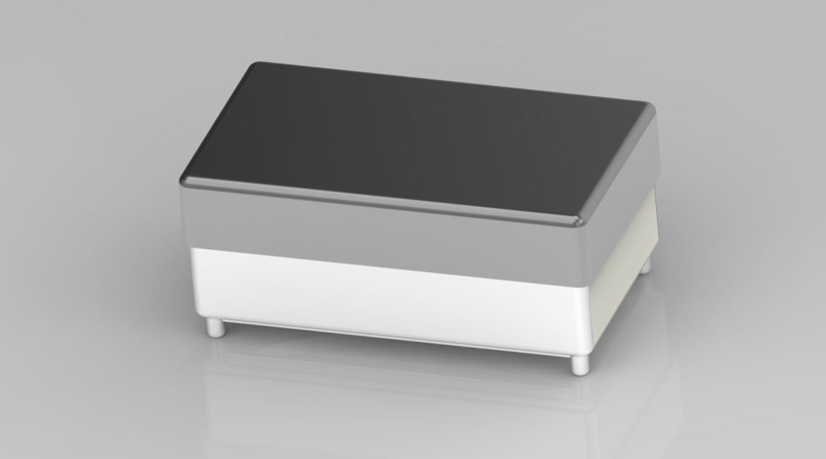

For smoothest operation, please read the user manual to understand our product

Lux Case User Manual Table of contents

Set Up and Use…………………………..3

Maintenance……………………………...4

User Safety Information…………………5

Warranty…………………………………..6

Service Center……………………………7

Replacement Part Information………….8

Set Up and Use

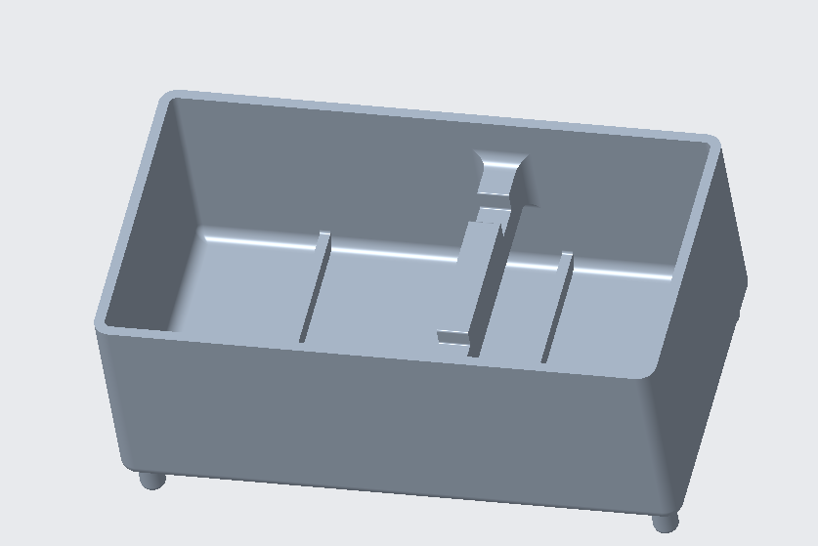

We have made setting up and using your new Lux Case very easy, as there are only two (2) parts to our design: the case and the lid. Firstly, the case itself, where you would put your toiletries in one of the three sections in the bottom of the case, the three sections allowing you to separate your effects.

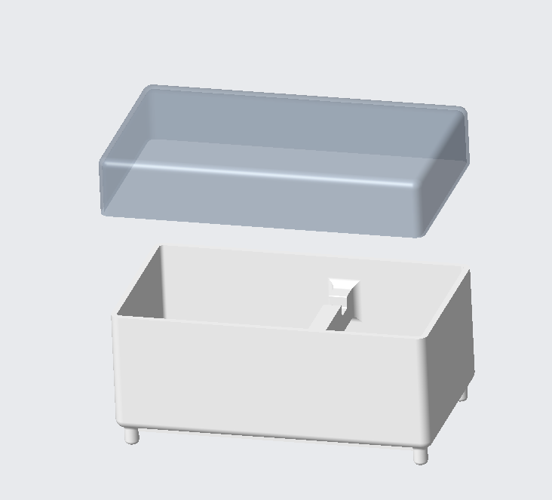

Then you would place your toothbrush and razor on the elevated section, allowing those to also be separated. Finally you would align the lid (shown at the top of the above image) and the case (shown at the bottom of the above image) and secure the two together and it's ready to go!
Maintenance

Ensuring the functionality of the Lux Case is easy, as there is almost nothing to fix besides replacing a broken lid or case, so you can enjoy worry-free use of our product!

Although we do recommend cleaning both the case and the lid bi-weekly as grime and such can build up, possibly leading to you getting sick due to bacteria getting on your toothbrush and other toiletries.

NOTE: To find information about replacing a broken lid or case, refer to the “Replacement Part Information” section on page 8 for more information.

User Safety Information

Although the Lux Case is a fairly simple design, you still have to be careful about closing your fingers in the Lux Case, to ensure you don’t do this make sure your fingers aren’t in the way of the lid and the case when closing.

CHOKING HAZARD: The elevated surface can be broken off and possibly swallowed by small children, keep away from children five (5) years old or younger.

Warranty

The warranty we offer with the Lux Case is a lifetime guarantee, we believe that our product under normal circumstances shouldn’t break*, but if it does, just give us a call and we’ll replace your broken parts free of charge! Refer to page 8 for more information.

*Your warranty can be voided if the Lux Case was broken in a way that is outside of normal use that lead to its breaking, rather than just a faulty part leading to the product breaking, in this case your warranty will no longer be valid for your product.

Service Center

At the time of this manual's creation (2023) all information is correct, but please refer to our website for the most accurate email, phone number, and mailing address.

Website:
https://webpages.charlotte.edu/achappid/home.html

Phone Number:
704-LUX-CASE

Address:
9201 University City Blvd.
Charlotte, NC 28223

Operators:
Here are our top operators who work 24/7 to provide you with excellent service and ensure our product is functioning properly.

Jake Mangum: Chief CAD Designer, jmangu19@uncc.edu

Akhi Chappidi: Chief Website Designer, achappidi@uncc.edu

Noah Stuart: Author of User Manual, nstuart3@uncc.edu

Jake Sowards: CAD Designer, jsoward@uncc.edu

Replacement Part Information

In order to get a replacement part you can contact one of our operators, on page 7, 24/7 and if it is a warranty part replacement then our operators will help you start the process of submitting your claim, but if you are just wanting to order a replacement lid or case our operators can also help you order a replacement part.

Our design only has two (2) parts to replace, the lid, at $2.00 for a replacement, and the case itself, at $4.00 a piece.

